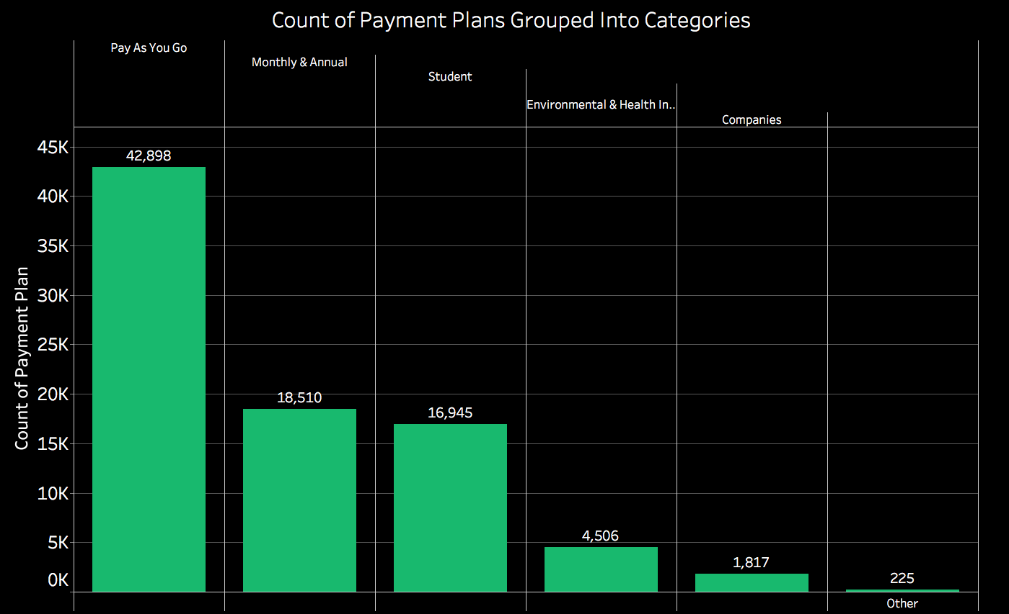

Count of Payment Plan

Pass Categories

Other

Monthly & Annual

Environmental & Health Initiatives

Pay As You Go

Student

Companies